3.4 Lakehouse vs Warehouse vs Eventhouse

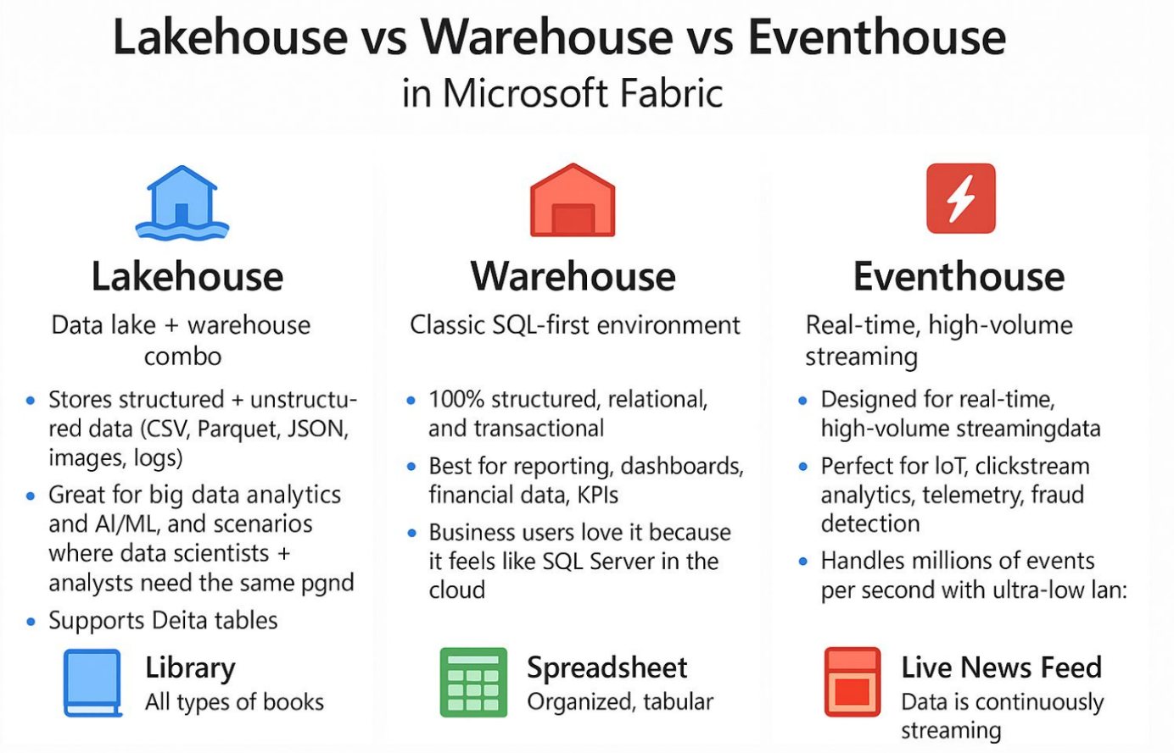

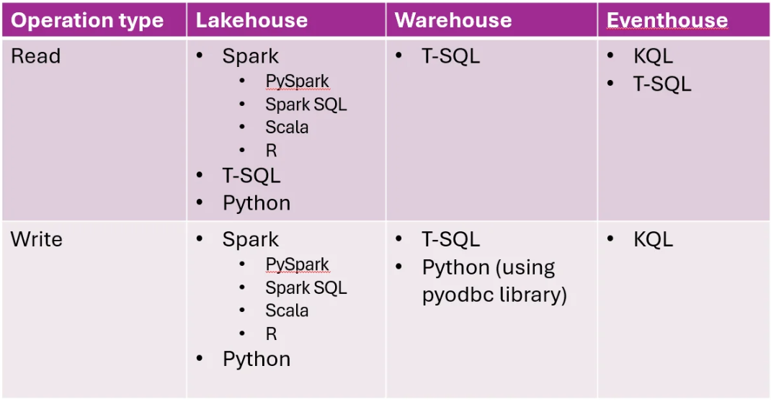

Note: In Microsoft Fabric, Lakehouse and Warehouse store data in Delta Parquet format in OneLake, while KQL databases (Eventhouse) use a separate internal storage format managed by the Kusto engine, optimized for real-time analytics.

